Table of Contents
Exercise notebook code and output 2
Documentation 3
Presentation 20

Exercise notebook code and output
All work files, including report and notebook are located here in GitHub
https://github.com/mramsundar/IITM-Graded-Projects/tree/b85e06634a085b93155c455db2371c45ddf3ad2b/Week%2031
Notebook file direct link
https://github.com/mramsundar/IITM-Graded-Projects/blob/b85e06634a085b93155c455db2371c45ddf3ad2b/Week%2031/tweet_anaysis.ipynb
PDF of the notebook
https://github.com/mramsundar/IITM-Graded-Projects/blob/b85e06634a085b93155c455db2371c45ddf3ad2b/Week%2031/tweet_anaysis.pdf

Documentation
- My approach started with defining a set of global constants, that could be then reused in multiple places across the notebook.
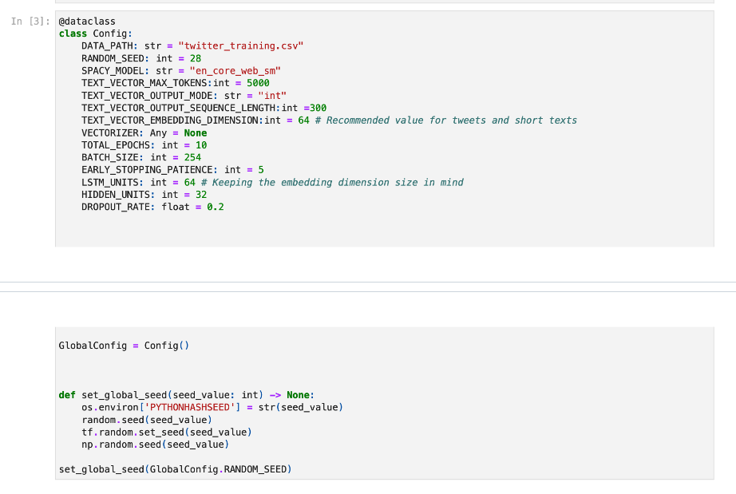
- Dataset was then loaded and basic cleanup process started, including setting headers, removing duplicates
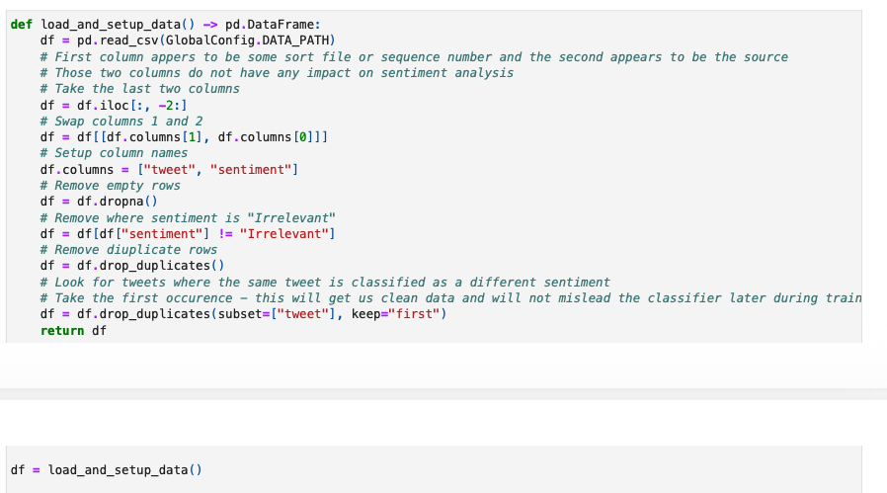
- Since this is a sentiment analysis project, the next step was to take what is essential from the tweets. SpaCy was used to lemmatize the text
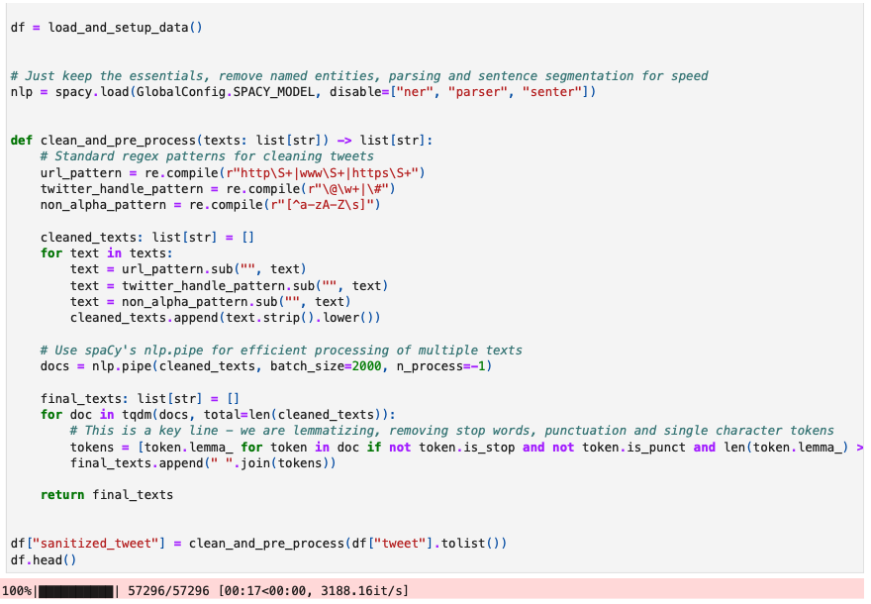
- Next is feature engineering. We transformed the cleaned-up tweet into a sequence of integers. These would later be converted into embeddings when we construct our RNN
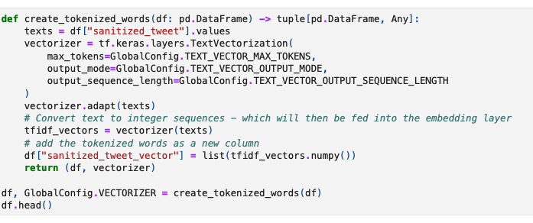
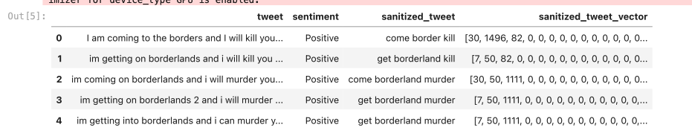
- During EDA, it was observed that the sentiments were fairly well distributed
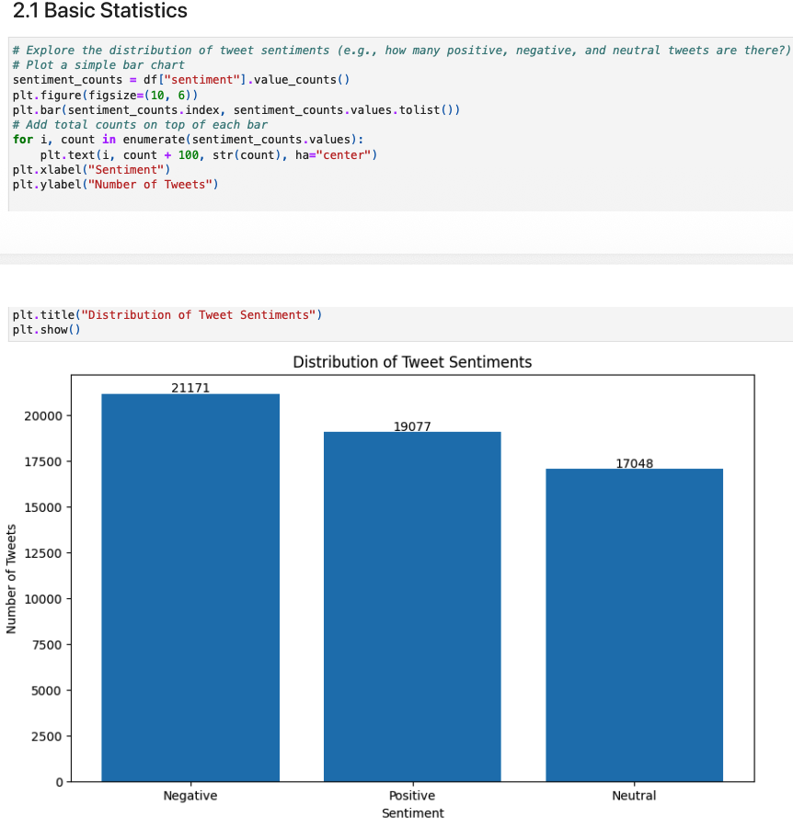
- Bar charts with word frequencies and word clouds were created next
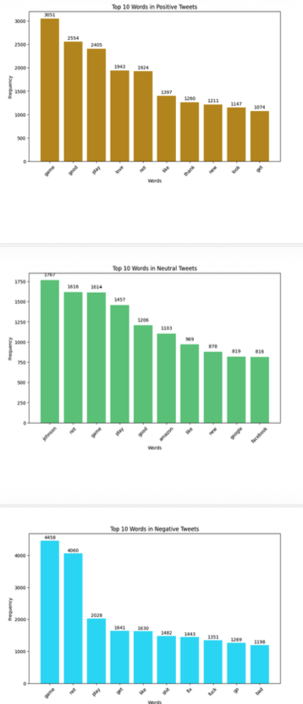
- Word clouds
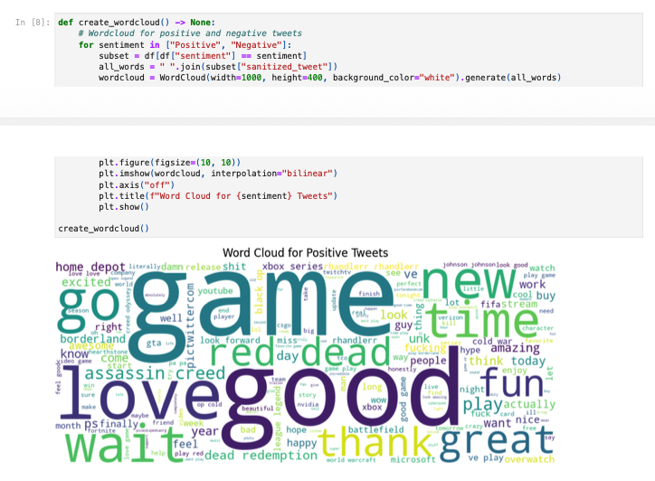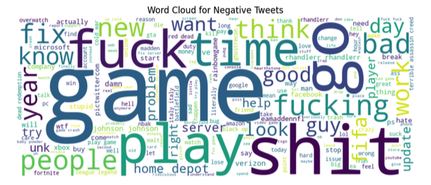
- Last step of EDA was to look at the relationship between tweet length and the sentiment. It was observed that there is no obvious relationship
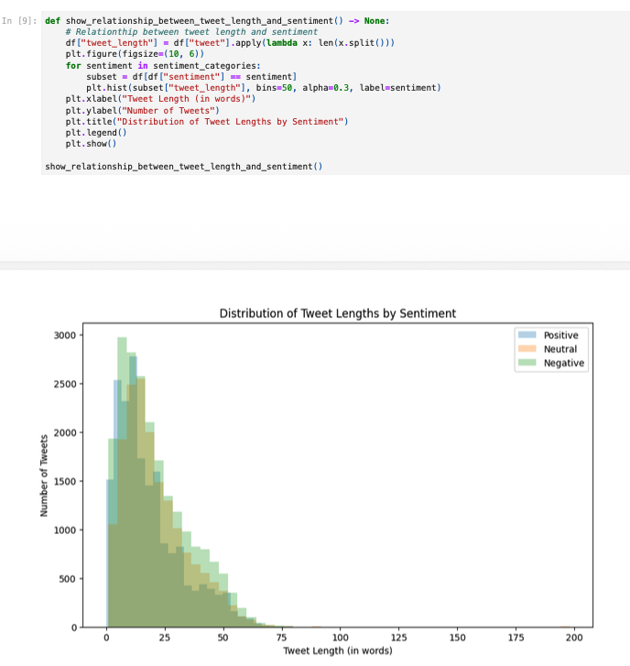
- The following is the RNN model architecture (created in Mermaid format based on the Python code) with ~400K trainable parameters
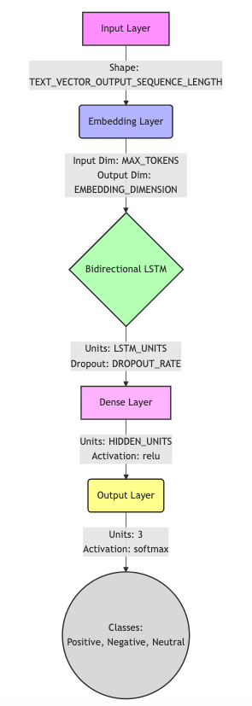
- Model code
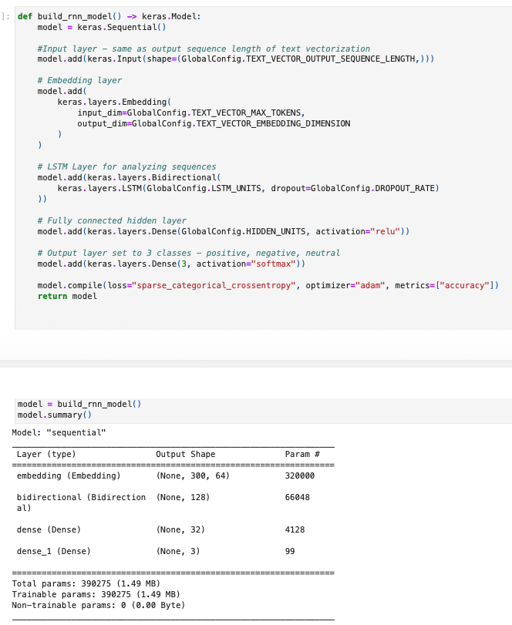
- Before model evaluation, final data preparation was implemented to map sentiments into integers and getting X and y values
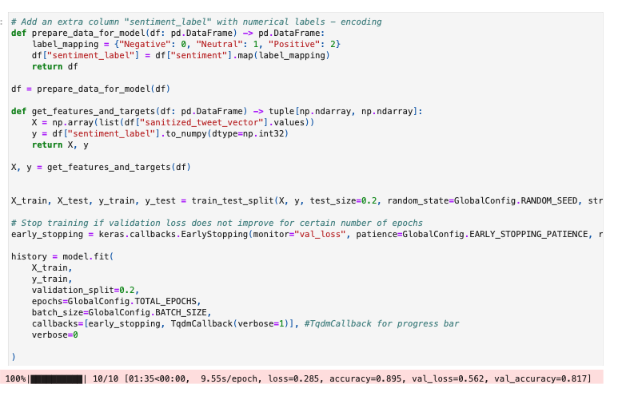
- Key points on model training
  - Early stopping was implemented to ensure model does not overfit
  - 10 Epochs were chosen based on industry standard practices for twitter sentiment analysis recommendations
  - ~82% val_accuracy was obtained after this round of training
- Model evaluation was done by analyzing training and validation loss on the one hand and training and validation accuracy on the other. Through this, Epoch 7 was identified as the right number as it gave the lowest validation loss
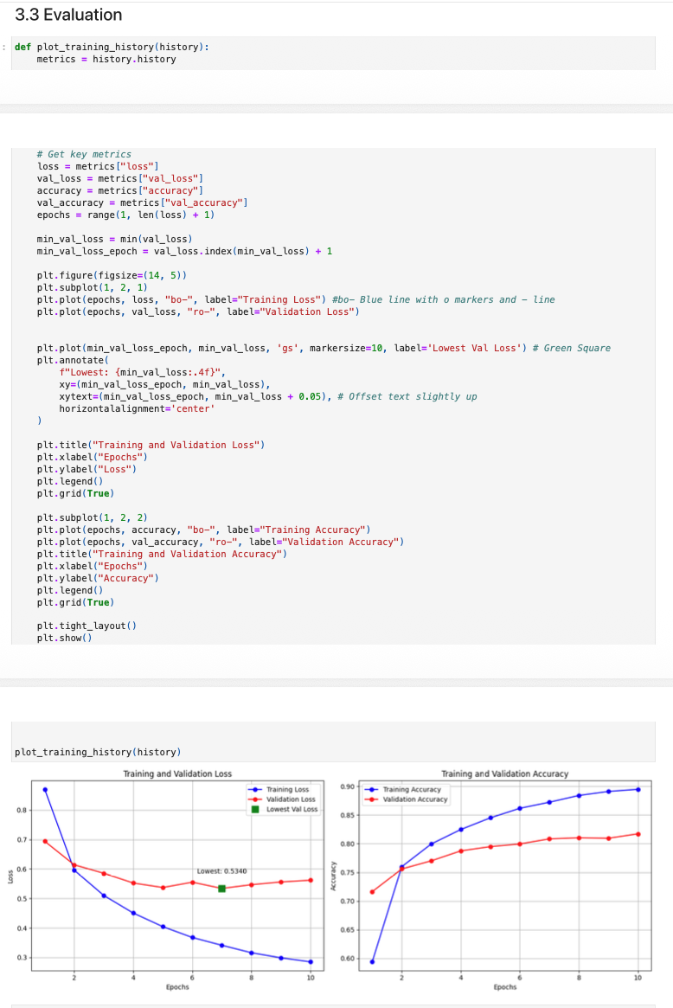
- To make things more interesting, we went ahead and completed all 10 Epochs and performed a what-if analysis
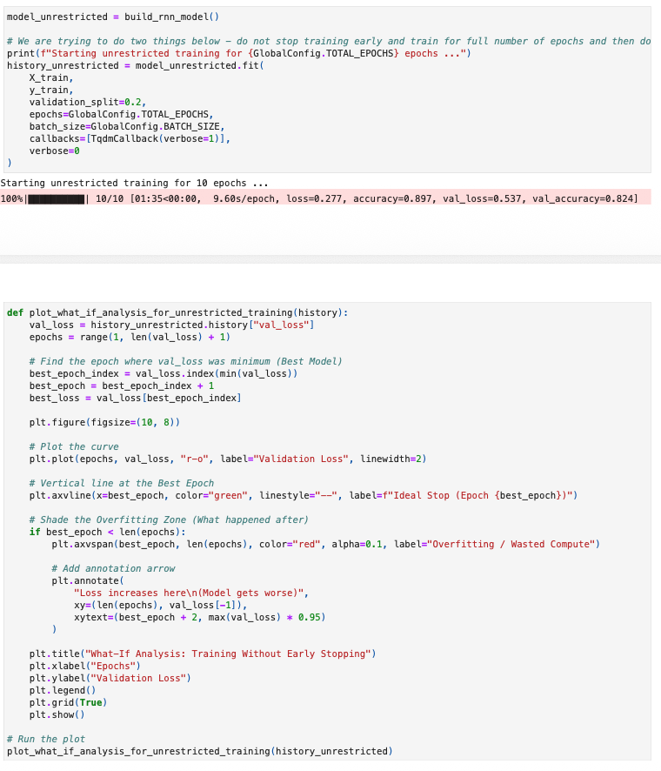
- This also confirmed our earlier finding that beyond Epoch 7, our returns were diminishing
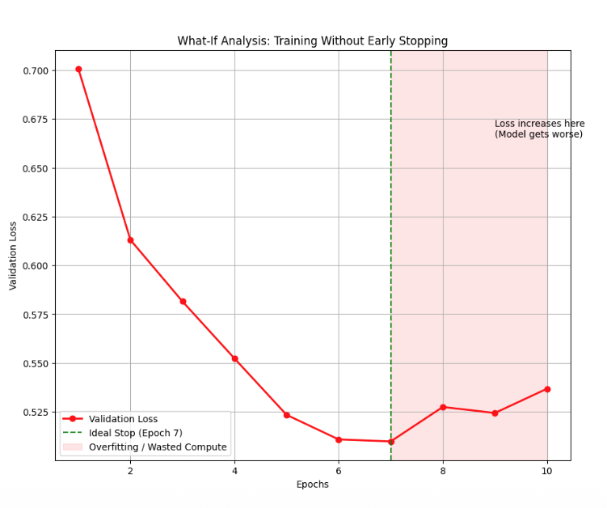
- Model Cross Validation was then performed to find out how model behaves for un-seen data outside the validation dataset. This also yielded ~83% validation accuracy – further attesting the fact that our training is very solid
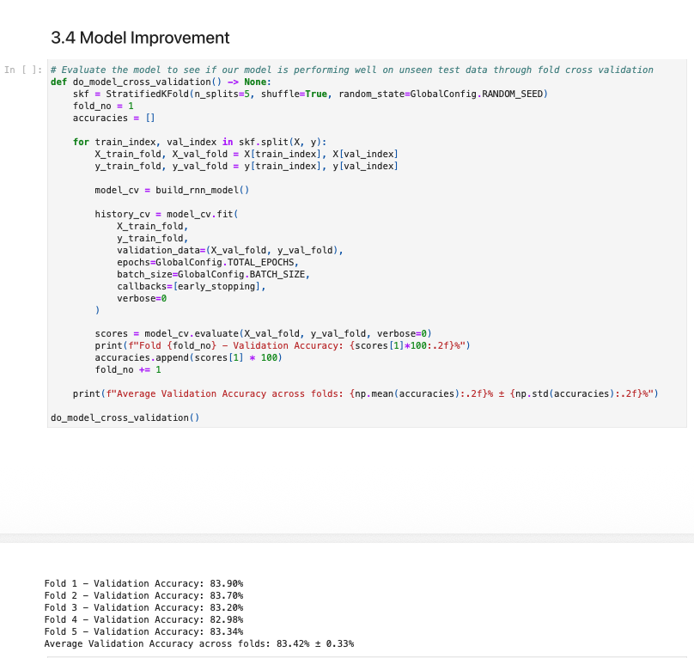
- For tuning the hyper parameters, Grid Search was performed next to determine the right combination of LSTM, Hidden layer units and Dropout rates. 64 was kept as the embedding dimension, the LSTM and hidden layer units to align with industry standard recommendations in this space. 0.2 was identified as the optimal dropout rate yielding ~81% accuracy
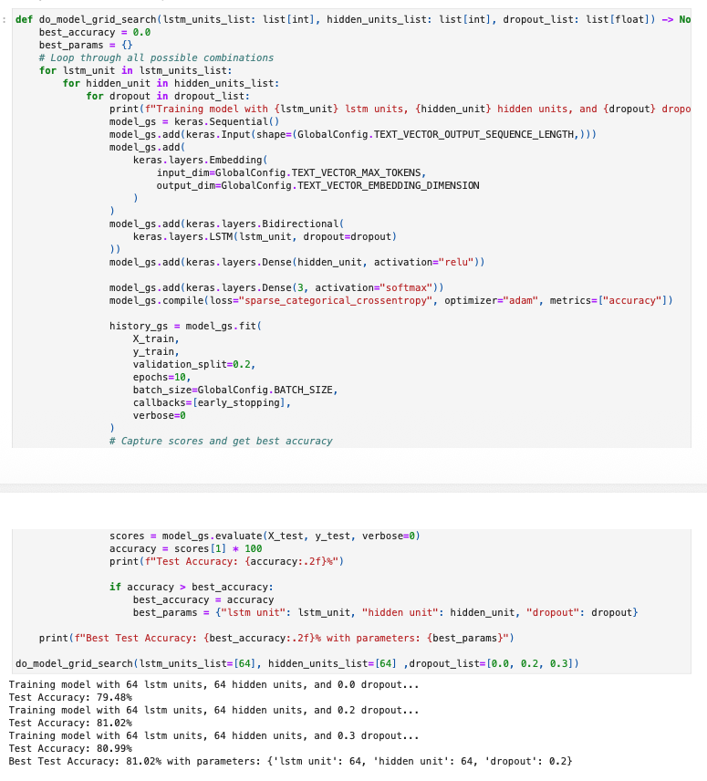
- A benchmark test was performed with twitter data from NTLK to test our model strength. The outcome of the test was moderate at best. This indicates that our training data is fairly domain specific and needs to be utilizing transfer learning by taking into consideration a wider vocabulary
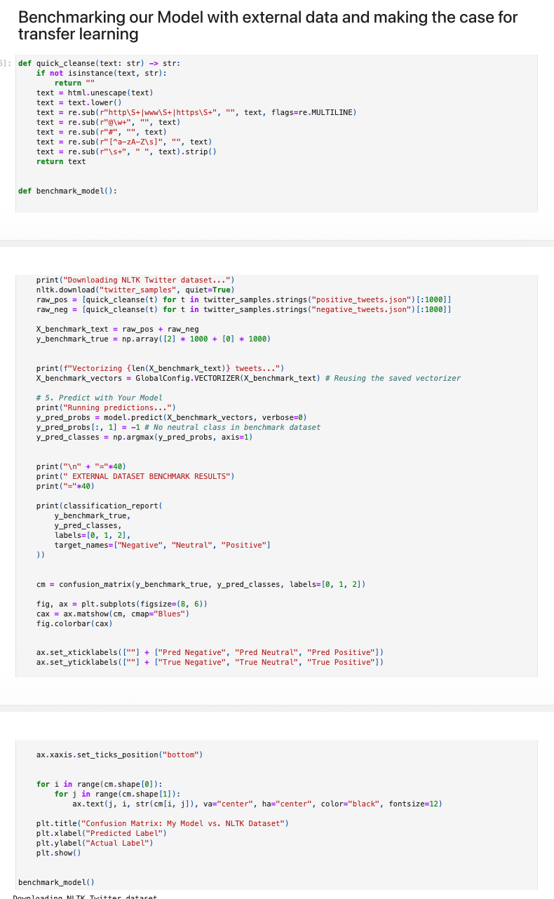
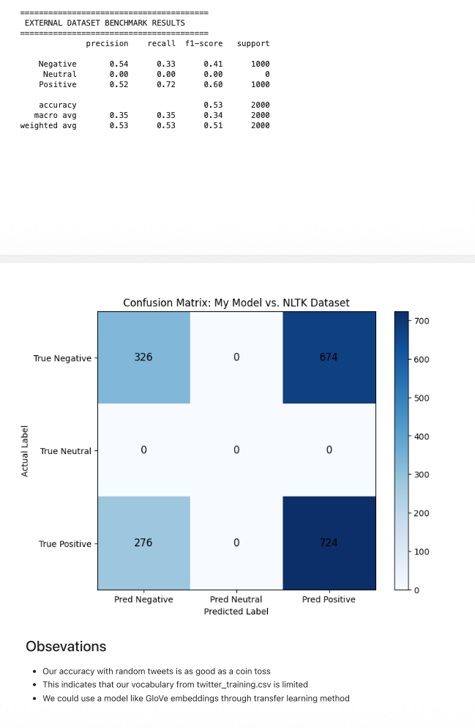
- Finally, a quick test with sample tweets were performed and the model performed as expected
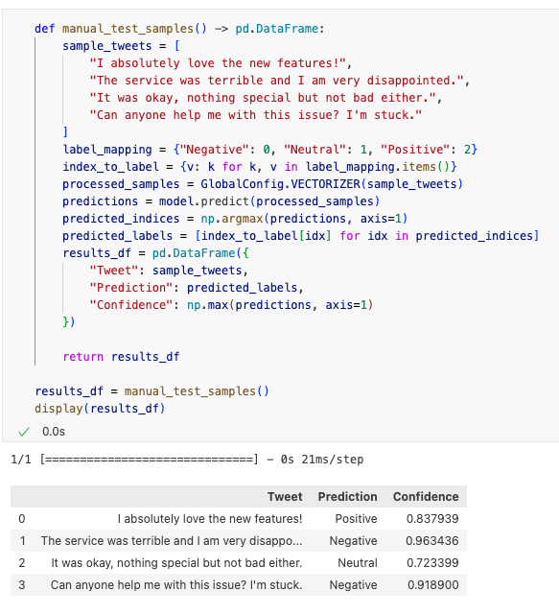

Presentation
Presentation is located here in GitHub
https://github.com/mramsundar/IITM-Graded-Projects/blob/6a096e27a9668d15625960044c06793aa6f87541/Week%2031/Week%2031%20Summary%20Presentation.pdf

